clip-on installation directions

******** These clip-ons are universal; there is NO right or left side ********
- Remove item from box and make sure all components and fasteners are present.
A. Handle bar: qty. 2 pieces
B. Bar cuff half: qty. 2 pieces
C. Bolt cuff half: qty. 2 pieces
D. M8 x 1.25 x 40mm long stainless steel flat head allen bolt: qty. 2 pieces
E. M5 x .08 x 16mm long stainless steel allen head bolt: qty. 4 pieces

Note: contact www.apexmfg.com for individual part replacement

Insert handlebar A into bar cuff B.
- Rotate handlebar A to desired position.
- Mate bolt cuff C to bar cuff B around fork tube using closest pin hole position.
- Apply 1-2 drops of thread locker (recommended) to flathead bolt D and install into handlebar end through both bar cuff B and bolt cuff C. Only snug bolt at this time.
- Apply 1-2 drops of thread locker (recommended) to both-M5 bolts E, install through bar cuff B into bolt cuff C. Only snug bolts at this time.
- Adjust clip-on to desired location on fork tube.
- Tighten M8 flat head bolt D to 15ft lbs.
- Tighten both M5 bolts E to 8 ft lbs.
- Tighten M5 bolts E to 9 ft lbs
- Tighten M5 bolts E to 10 ft lbs.
- Repeat steps 8 and 11 to insure proper tightness.
- Repeat steps 2 through 11 for opposite side, making sure to use pin hole exactly 180 degrees from side assembled first.

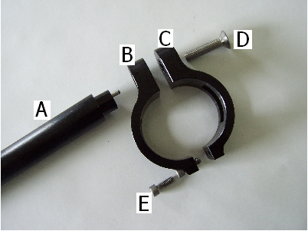

***Before operating motorcycle, make sure all cables and brake lines are free and have full range of motion with out binding. Failure to due so could result in serious injury or death. Apex Manufacturing LLC is not responsible for misuse of this product. For normal street use only.***

